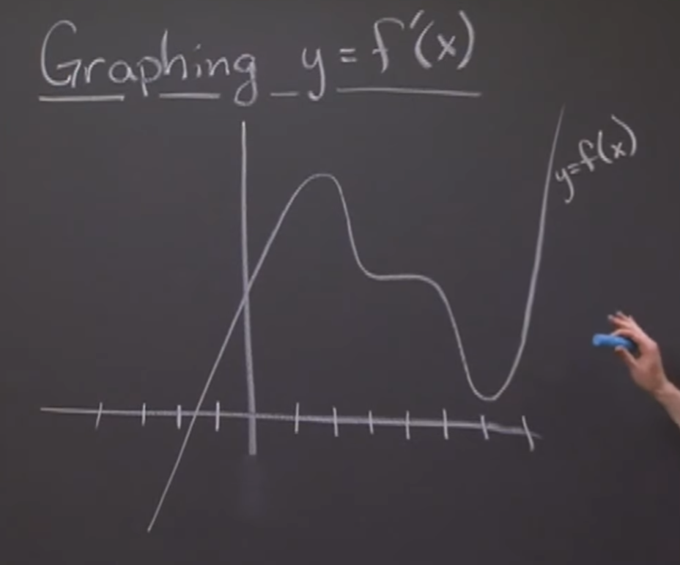

1. Find all zero slopes – easiest
   1. This is where you change the sign of the derivatives

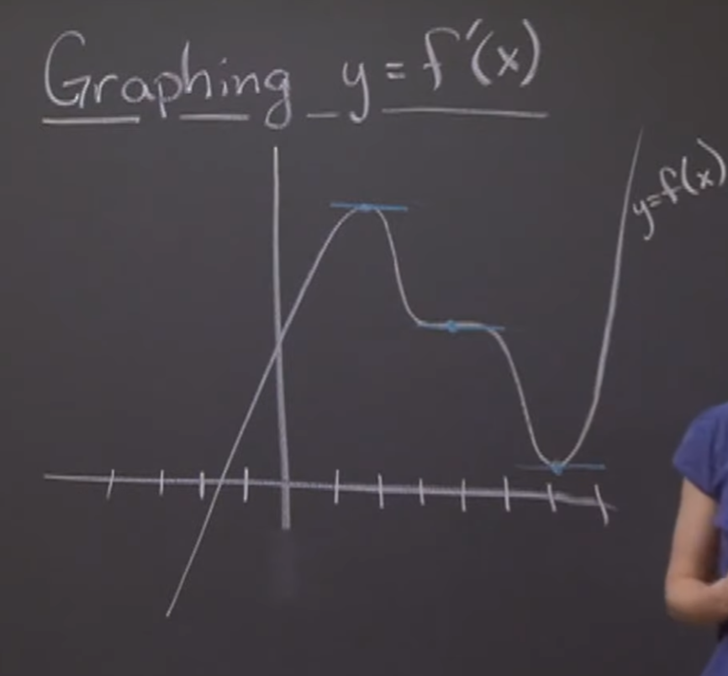

1. Where are positive and negative regions

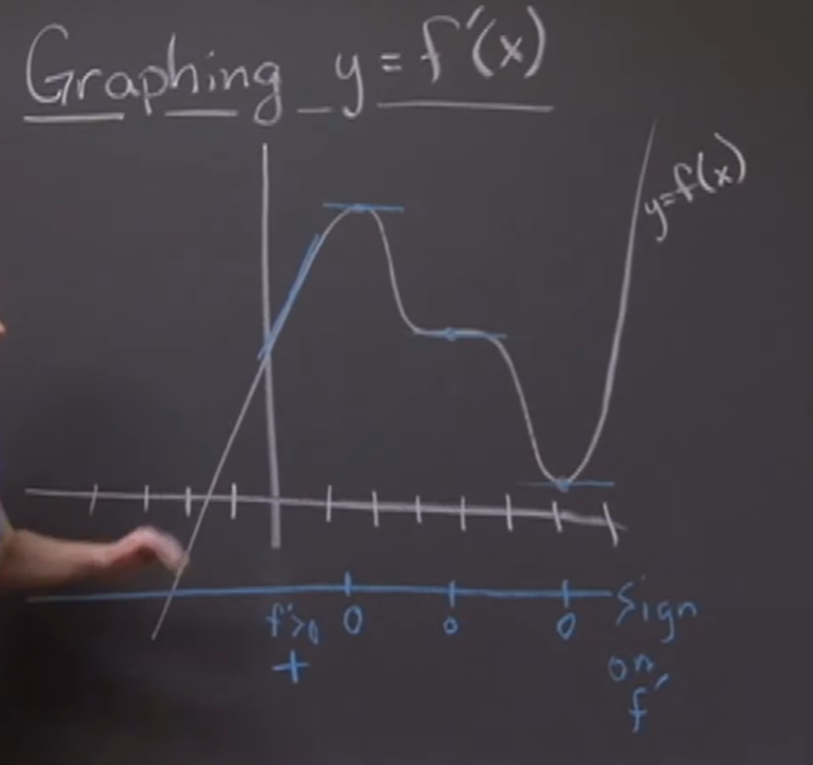 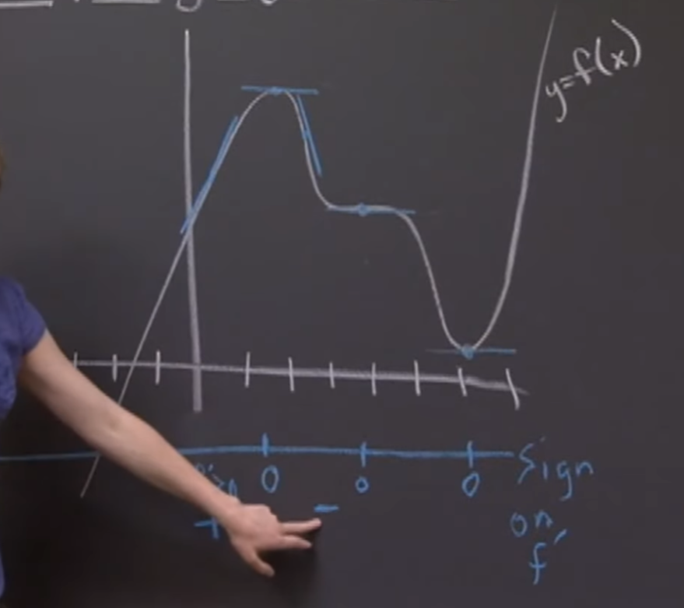

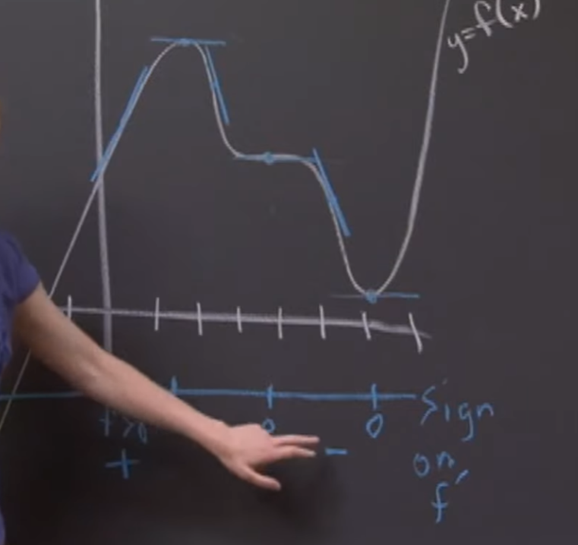 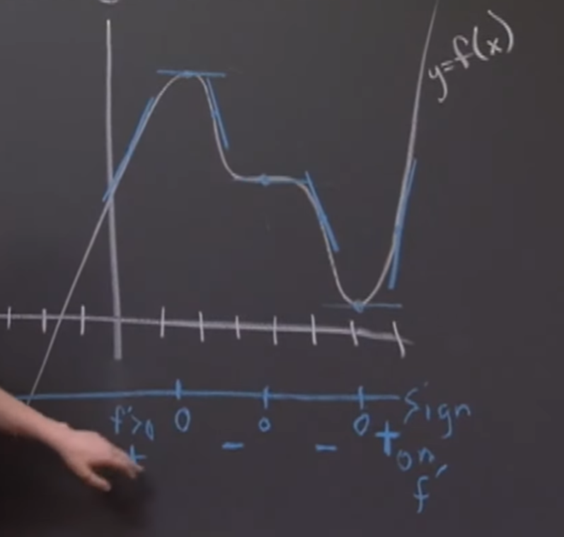

1. Draw the points of the derivative of 0

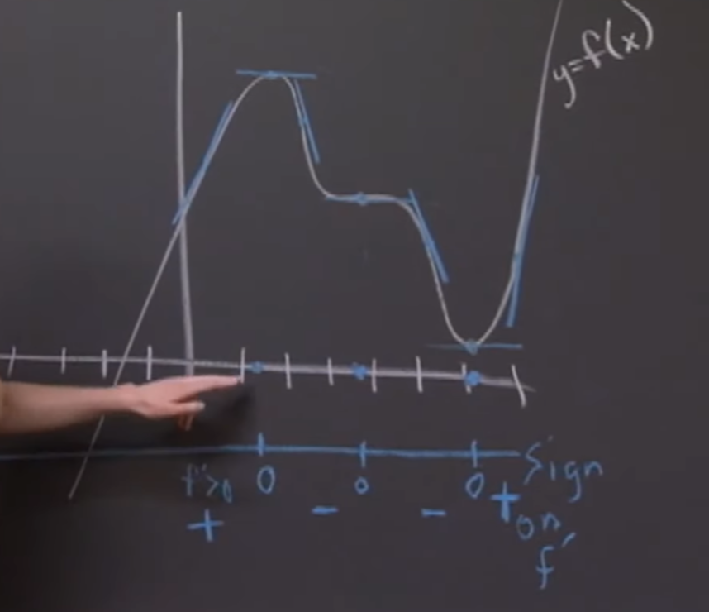

1. Draw each region
   1. First region (+ going to zero)

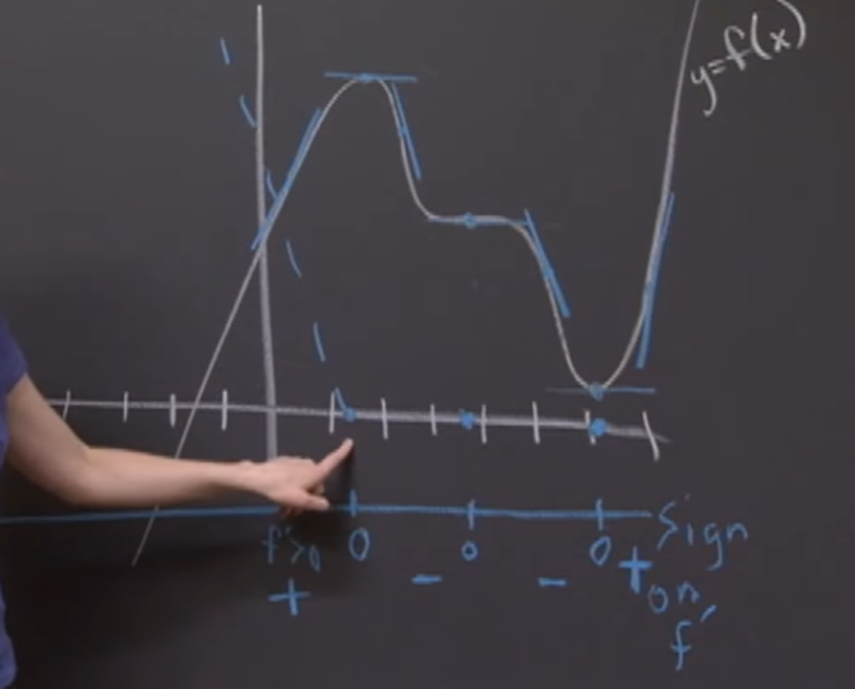

* 1. Second region (- from 0 going to 0)

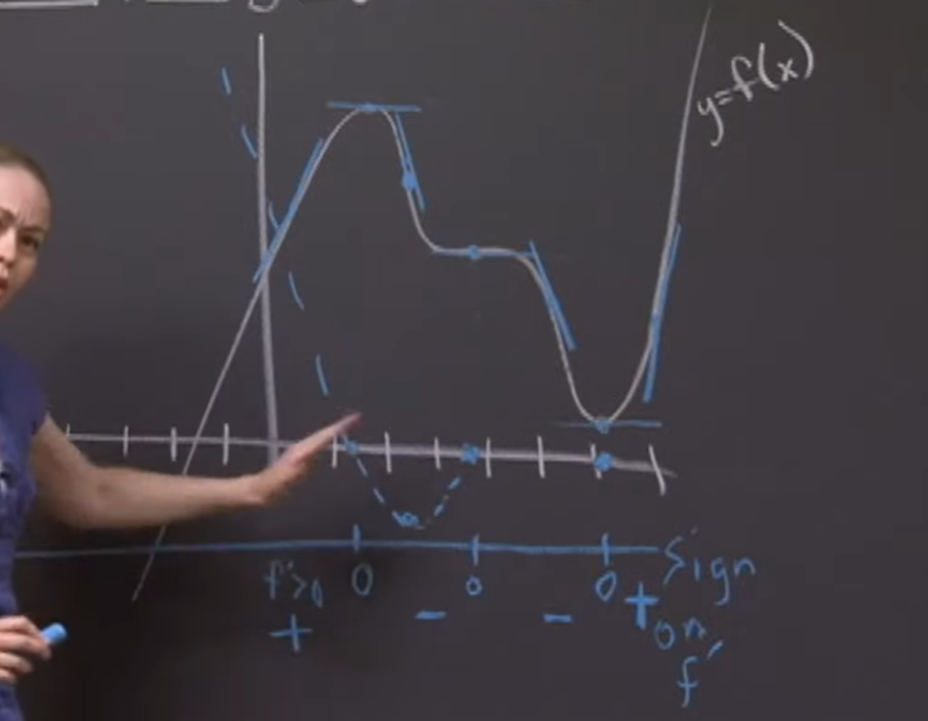

* + - The max negative is assumed where it will come back up to 0
  1. Third region (- from 0 going to 0)

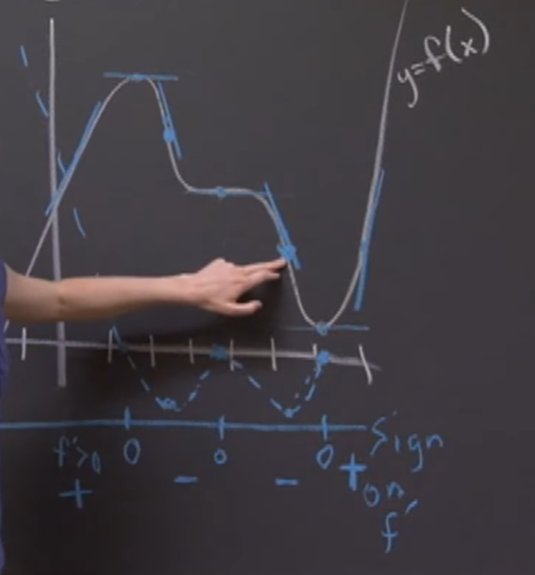

* + - The max negative is assumed where it will come back up to 0
  1. Fourth region (+ from 0)

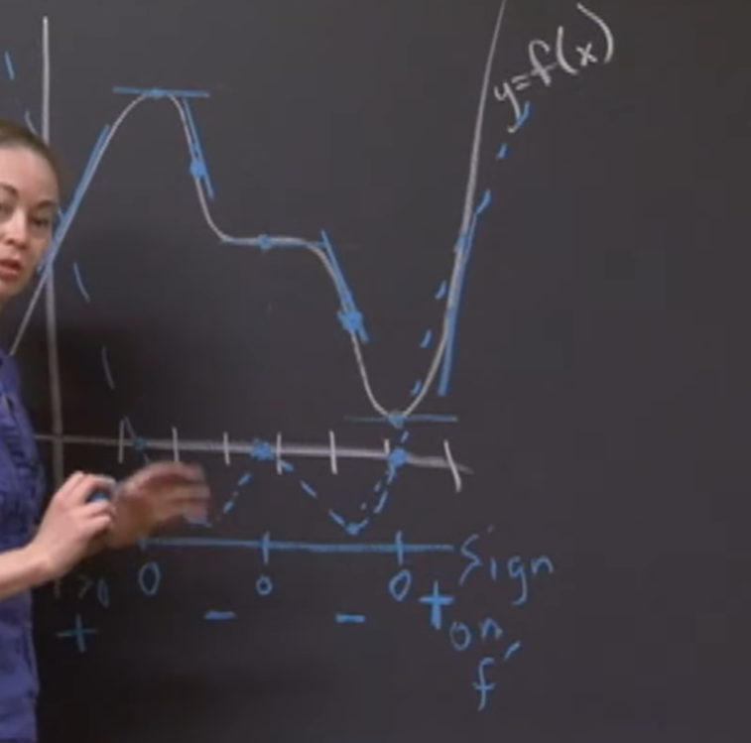

1. Final result:

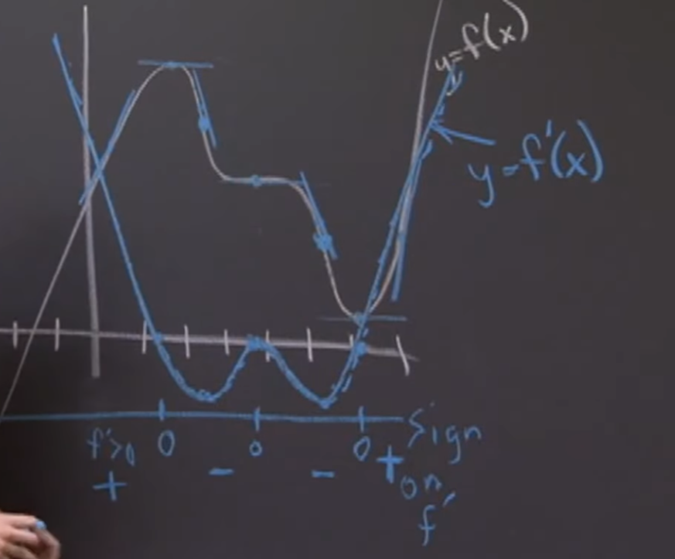

Question:

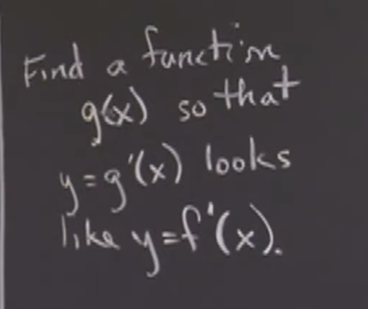

* Take function f(x) and add a CONSTANT to it
  + g(x) = f(x) + C
  + The constant will be responsible to a shift up or down of the WHOLE graph of f(x)
* The derivative of f(x) is equal to the derivative of f(x) + C